

Hill Top

Curriculum Policy

|  |  |  |  |
| --- | --- | --- | --- |
| Signed by: | | | |
| Anita Bell | Headteacher | Date: | February 2024 |
| Sharon Redhead | Chair of governors | Date: | February 2024 |

**Contents:**

1. Context
2. Curriculum intent
3. Legal framework
4. Roles and responsibilities
5. Organisation and planning
6. Subjects covered
7. Reporting and assessment
8. Equal opportunities
9. Monitoring and review

## **School Context:**

Hill Top School is a special school for pupils aged from 11-18. At Hill Top School we support pupils with a range of learning needs including, autistic spectrum condition (ASC) and associated learning difficulties, as well as other specific neurodiverse conditions, such as ADHD. Most of our pupils also have communication difficulties and some have moderate learning difficulties (MLD). Classes that follow our formal pathway are grouped primarily on age, pupils in our autism centre, who follow the informal and semi-formal pathway, are groups according to learning needs. We have a post-16 provision, including autism specific 6th form.

Due to the complex nature of the pupils that attend Hill Top, it is our responsibility to provide them with the most appropriate curriculum, a tailored approach, to both academic learning, life skills and personal, social, health and citizenship education.

Our curriculum evolved after consultation with staff, parents and pupils, the outcome was that all stakeholders wanted a curriculum that addressed the needs of the whole child, not just academic progress, prepared pupils for their next step and for life beyond Hill Top.

**Vision, Values and Aims:**

“Believe, Achieve, Succeed”

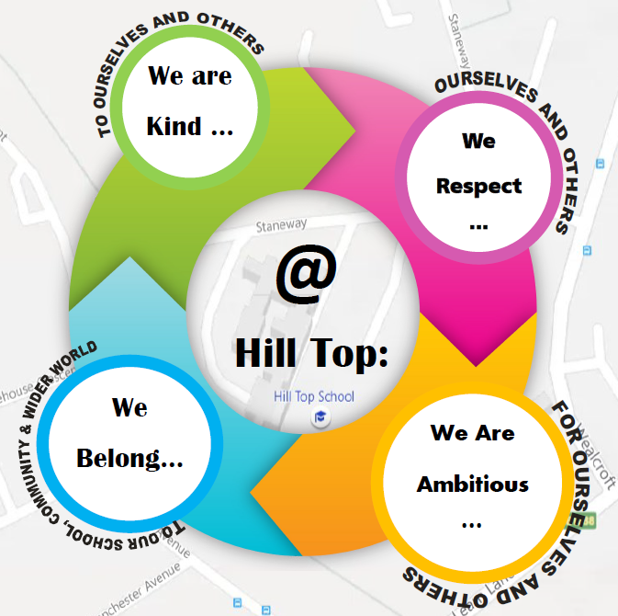

We believe that Hill Top is a safe, happy and stimulating school that supports pupil’s individual needs. The staff and the school community work hard to ensure that a nurturing approach supports all pupils through their education, providing a bespoke curriculum to each child depending on their current needs.

At Hill Top all aspects of school life are designed to inspire and engage pupils, through a mix of a learning curriculum, creative approaches and essential life skills. The roles of communication and engagement are key to all we do and underpin our approach to learning.

Our curriculum is designed as a cohesive approach with an individual’s EHCP at the core; therefore, facilitating greater involvement of families, the pupil and other professionals in their learning and development. We provide positive challenges to foster individual achievements and promote confidence and self-expression. This allows the curriculum to show progress of pupils over time; celebrating the challenging, enriching and developmental progress of all pupils.

Our curriculum is developmental, but child centred, with our recognition that each pupil will have a different pathway. It is a life skills and creative curriculum that aims to promote the social inclusion of all pupils and prepare them for the opportunities, responsibilities and experiences of adult life as pertinent to their circumstances. As the pupil’s move through the school, the skills they need for living become an integral part of learning. These include;

• communication

• academic achievement in including as secure grasp of reading and maths

• qualifications where appropriate

• independence - including self-help

• relationships

* keeping themselves safe

• self-respect, dignity

• self-esteem, self-confidence

• self-regulation.

The Hill Top curriculum, is an adapted form of the National Curriculum and whilst some of the curriculum areas do not appear ‘traditional’ it addresses the expectations of the new National Curriculum 2014;

“Every state-funded school must offer a curriculum which is balanced and broadly based and which:

* Promotes the spiritual, moral, cultural, mental and physical development of pupils at the school and of society, and
* Prepares pupils at the school for the opportunities, responsibilities and experiences of later life.

The school curriculum comprises all learning and other experiences that each school plans for its pupils. The national curriculum forms one part of the school curriculum. All schools should make provision for Personal, Social, Health and Economic education (PSHE), drawing on good practice. Schools are also free to include other subjects or topics of their choice in planning and designing their own programme of education.”

Although the National Curriculum and expectations it holds are taken into account, especially for those pupils on the formal pathway, for the pupils at Hill Top, it is often more important to consider their needs and the skills that will be supportive for the future;

“Content should be determined by the needs of the child rather than cultural values in respect to academic subjects and so it needs to be pupil centred and not subject centred.” (Powell and Jordan 1997:25).

# Curriculum intent

At Hill Top School, we have designed our curriculum with pupils’ learning at the centre. We recognise that a curriculum has to be broad, balanced and offer pupils opportunities to grow as individuals as well as learners. Our school values the input of its pupils, parents and the local community with regards to the planning and delivery of the curriculum. We believe pupils get a well-rounded education if everyone is involved in shaping it.

It is our intention to provide a curriculum model that is primarily focussed on Preparation for Adulthood and preparing pupils for the next steps, whether that is the next Key Stage of their development or for their subsequent steps in life.  For some this may be college or work based learning, whilst for others it may be preparing them for adulthood, with as much relative independence and communication skills to ensure their safety and enrich their lives.

Our thoughts on curriculum design are that the current school cohort (and indeed, cohorts for the foreseeable future) are not best served by the National Curriculum alone. Our experience, concurring with a number of outstanding special schools, has led us to adopt a much more flexible and personalised approach, which sees our curriculum changing to meet the needs of the pupils rather than the other way round. Our learners are at the centre of our curriculum design.

We aim to ensure pupils enjoy learning and feel prepared for life after school. We also intend to offer our pupils new and exciting experiences through enrichment opportunities that are designed to build resilience, confidence and self-esteem. Our curriculum will be delivered in accordance with the Equality Act 2010, through a variety of methods.

We are currently implementing 3 pathways, within our curriculum as set out below, although we are aware that some pupils with complex needs may move between pathways at times.

1. **Informal Pathway**

A highly individualised approach, providing a suitable learning environment to meet the complex needs of pupils. Preparation for Adulthood for these pupils might be developing independence, developing communication strategies and choice making, to ensure pupils are able to enjoy happy and healthy lives. Staff are extensively trained to meet the medical, physical, communication and sensory needs of learners and activities are designed to build upon this foundation, in an appropriate, cross-curricular and highly sensory manner, with real life contextual experiences. Pupils work in a non-subject specific way and staff use elements of the engagement model, as well as strategies such as intensive interaction and attention autism, to underpin their planning for pupils.

1. **Semi Formal Pathway**

A holistic approach that makes links between key areas of curricular learning, in a creative and life skills context. To prepare these pupils for adulthood, there is an emphasis on independence, problem solving and communication skills, which are encompassed in the classroom and beyond, with regular access to the community to generalise their skills to real life contexts. There is a commitment to cross-curricular and contextualised learning where pupils are engaged and enthused in real life situations, within a flexible framework which is responsive to their personalised needs. The concepts of over learning and repetition are key in our semi-formal approach, to support the memory difficulties synonymous with pupils who have severe learning difficulties. To support the social and emotional needs of pupils, semi-formal groups are taught as individual classes, allowing consistency of teacher as support staff.

1. **Formal Pathway**

A subject specific approach that encompasses many elements of the National Curriculum, where appropriate for our pupils. The majority of pupils in this cohort continue their learning beyond Hill Top with appropriate providers or colleges. Support staff are designated to each group to maintain close relationships and ensure we continue to support the Social and Emotional needs of pupils. Pupil in the formal pathway will access accreditation where appropriate, to allow them to gain employment opportunities. These pupils are also supported to develop their independence in all areas of their life, to achieve independent living in adulthood.

KS3 and KS4 curriculum

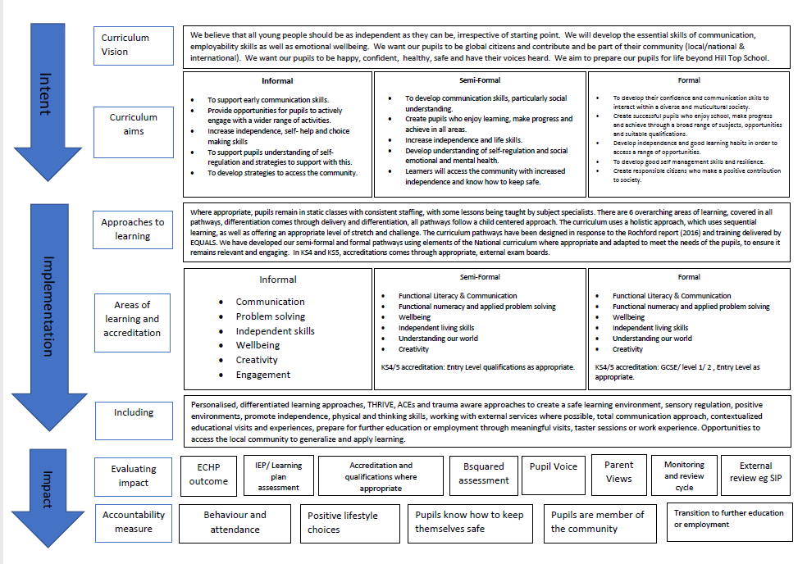

**Post- 16 provision**

Hill Top school has a small 6th form provision available for those pupils who need further support academically to achieve qualifications, before moving on to their next step. There are also pupils who aren’t socially or emotionally ready to access a college course and need additional time in a more nurturing environment. For those pupils in our autism centre we have an autism specific 6th form (from September 2021). In KS5 we continue with 3 specific pathways and the focus for all 3 is preparing for adulthood, on a level that is specific to the individual pupil.

KS5 curriculum

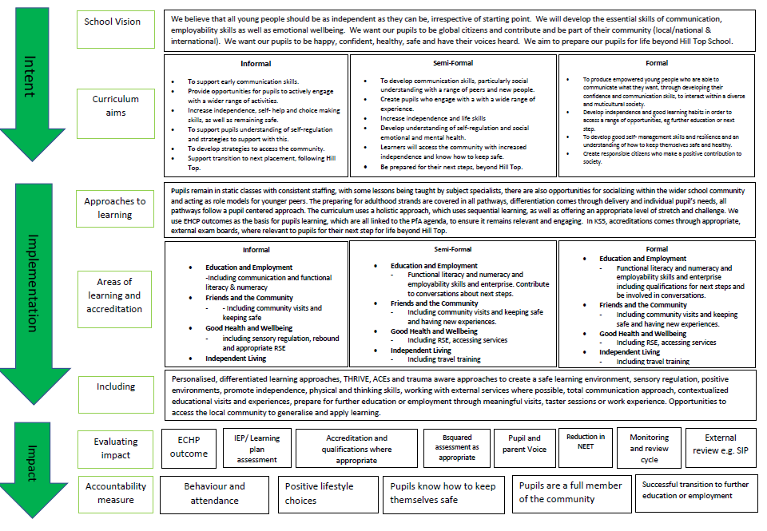

# Legal framework

* 1. This policy has due regard to all relevant legislation and statutory guidance including, but not limited to, the following:
* The Education Act 2002
* The Children Act 2004
* The Equality Act 2010
* DfE (2017) ‘Special educational needs and disability code of practice: 0 to 25 years’
* DfE (2013) ‘The national curriculum in England’
* DfE (2017) ‘Statutory framework for the early years foundation stage’
* DfE (2019) ‘School attendance’
  1. This policy operates in conjunction with the following school policies:
* Assessment Policy
* Equality Policy
* PSHE Policy
* Relationships, Sex and Health Education Policy

# Roles and responsibilities

* 1. The governing board is responsible for:
* Approving and monitoring the content of this policy.
* Liaising with the headteacher, TLR holders and teachers with regards to pupil progress (academic and EHCP)
* Ensuring the curriculum is inclusive and accessible to all.
  1. The Curriculum Lead is responsible for:
* Creating and maintaining an up-to-date curriculum intent statement.
* Ensuring the curriculum is created in accordance with this policy.
* Updating and maintaining this policy.
* Attend meetings with the SIP and external visitors to support TLRs in discussion regarding the curriculum.
* Making any necessary adjustments to the curriculum where required or sharing these with appropriate TLR holders and ensuring changes are made.
* Keeping up-to-date with any relevant statutory updates and taking action where required, including reporting to the appropriate people.
* Reviewing the curriculum to ensure it meet the needs of changing cohorts.
  1. SLT are responsible for:
* Supporting TLRs to monitor the implementation of their curriculum area and ensure expected progress is happening.
* Communicating the agreed curriculum to the governing board on an annual basis.
* Ensuring the curriculum is inclusive and accessible to all.
* Ensuring the curriculum is implemented consistently throughout the school and ensuring any difficulties are addressed and mitigated as soon as possible, arranging additional training as needed.
* Receiving reports on the progress and attainment of pupils and reporting these results to the governing body.
* Keeping up-to-date with any relevant statutory updates and taking action where required.
* To ensure the staff team have the correct CPD to develop their skills and be able to deliver the curriculum appropriately.
* To make sure TLRs have protected time to deliver their curriculum appropriately.
* Ensuring teaching materials do not discriminate against anyone in line with the Equality Act 2010.
  1. TLR holders are responsible for:
* Providing strategic leadership and direction to their team and colleagues.
* Designing a curriculum, which clearly outlines the key learning expected to me made by pupils, within the unit, as well as over the course of the year and as they move through key stages. This will include long and medium term plans including vocabulary, key objectives, activities and resources. These must be detailed enough for staff to be able to differentiate the learning to their own class.
* Supporting and offering advice to colleagues on issues relating to the subject or curriculum area, including running CPD and training for staff.
* Knowing what progress looks like within their area and monitoring pupil progress within their area of responsibility and creating plans to resolve any issues and support colleagues.
* Providing information to exams officer as relevant for their area on exam entries.
* Providing efficient resource management for their department.
* Ensuring the curriculum is inclusive and accessible to all.
* Ensuring there are specialist resources and equipment available for pupils in need so that everyone can have full access to the curriculum.
* Report on curriculum implementation in their area to SLT.
* Keeping up-to-date with any relevant statutory updates and taking action where required.
  1. Teachers are responsible for:
* Implementing this policy consistently throughout their practices.
* Ensuring lesson plans are reflective of the school’s curriculum and meet the needs of their pupils. Plans should take into account the curriculum design of the TLR or area leader and include key learning that is highlighted.
* Implementing the curriculum in ways that are suited to the learners needs.
* Collaborating with other staff to ensure that the curriculum is inclusive and accessible to all.
* Deploy staff effectively to ensure all pupils are supported.
* Differentiate work appropriately to the individual needs of the pupils.
* Celebrating all pupils’ academic achievements.
* Monitoring the progress of all pupils and reporting in line with school policy.
* Liaising/ referring to external agencies where necessary to ensure pupils who require additional support receive it.
* Keeping own knowledge of subject areas up to date, highlighting CPD needs.

3.5 Teaching assistants are responsible for:

* Supporting the class teacher to implement the learning with their group of students.
* Working 1:1, in small groups and whole class work, to implement the learning objectives as identified by teachers.
* To deliver interventions as needed.
* To record learning and gather evidence of learning, and feedback to teachers, to inform their planning.
* To keep their own knowledge up to date, in order to be able to effectively support pupils.
* To understand individual pupil needs as highlighted in EHCP outcomes and provision.

# Organisation and planning

* 1. The school’s curriculum will be delivered over 190 days.
  2. Each school day will be split into a morning and afternoon sessions and pupils will receive at least 2 breaks, as well as additional movement breaks or regulation opportunities as needed.
  3. The leadership team and external advisors observe lessons delivered by all teachers on a termly basis. This is part of a wide monitor and evaluation process which also includes: T&L walks, book scrutinise, planning scrutiny, triangulation of data, pupil voice etc.
  4. TAs and support staff are strategically placed to support learning as directed by class teachers and the leadership team.
  5. Lessons include a combination of whole-class, group and individual teaching – this is dependent on the nature of the group. It would not be uncommon to have several activities going on within class, there are not set time limits for learning activities.
  6. Clear routines are set out within each class, these are based on the needs of the group. They are based on the school core values/ethos of: **We are kind, We respect, We Belong and We are ambitious.**
  7. Expertly differentiated, personalised lessons are delivered in all classes. These are linked to curriculum and EHCP/learning plan targets.
  8. Opportunities to improve reading, communication and numeracy are provided throughout lessons where appropriate.
  9. Outside learning and Preparation for Adulthood are used to reinforce learning or used as opportunities to introduce or build on a skills/transferring of knowledge.
  10. Resources may be created for specific pupils – this might include the use of symbols, switch access, computer programs and/or access technology.
  11. All staff present themselves as a positive role model for our learners – always promoting the school core values.
  12. Due to the needs of our pupils and the flexibility required to deliver the curriculum, lessons aren’t time specific.
  13. Teachers will plan lessons to accommodate for pupils of mixed ability, making cross-curricular links, with application to real life, where possible.
  14. Pupils with EAL will be given the opportunity to develop their English ability throughout lessons where necessary.
  15. Planning will be used to identify any possible difficulties within the curriculum and will break down barriers to learning.

# Subjects covered

Each of the pathways covers 6 strands as appropriate. The strands include some of the adapted national curriculum subjects. These strands are always delivered with a focus on PfA and real-life application.

|  |  |
| --- | --- |
| **Functional Literacy & Total Communication** | Including phonics, reading, attention autism, TAC PACA and work with SaLT |
| **Functional Numeracy & applied** | Including applied problem solving |
| **Wellbeing** | Including: PE, PSHE including health, RSE, Careers/Employability |
| **Independent Living Skills** | Including: Food, community experiences/visits.  Independent travel (KS4 onwards) |
| **Understanding Our World** | Including: RS, History, Geography, ICT, Citizenship & Science |
| **Creativity** | Including: DT/Art/Music/ Drama |

Pupils will also have opportunities for enrichment activities each week, to allow them to try new experiences and develop new skills such as self-esteem and social skills.

The school day lasts between 8.45-3.00. This time is split differently according to which pathway the pupils are following, pupils on the informal and semi-formal curriculum will access sessions of between 20-30 minutes and pupils on the formal pathway access sessions of 40 minutes in the morning and 45 minutes in the afternoon.

On all pathways, there is some flexibility for staff to respond to the needs of the pupils and ensure they are regulated and ready to learn, before trying to engage them in academic learning. This might mean during some sessions, staff might use movement breaks, sensory circuits, snack or another strategy to support pupil’s readiness to learn, at some point during the lesson.

**Formal pathway:**

In KS3 and 4 learners accessing our formal learning pathway, have access to the weekly number of sessions, as stated below;

|  |  |  |  |  |
| --- | --- | --- | --- | --- |
| KS3 | |  | KS4 | |
| Literacy | 5 |  | Literacy | 5 |
| Numeracy | 5 |  | Numeracy | 5 |
| Science | 3 |  | Science | 3 |
| Humanities | 3 |  | Humanities | 2 |
| ILS | 4 |  | ILS | 5 |
| Art/ DT | 1 |  | Art/DT | 1 |
| PSHE | 3 |  | PSHE | 3 |
| PE | 2 |  | PE | 2 |
| Drama/Music | 2 |  | Drama/Music | 2 |
| ICT | 1 |  | ICT | 1 |
| PLL | 2 |  | PLL | 2 |

* + - **Art/Dt and Food technology are taught in a carousel on a half termly basis.**
    - **Some KS3 groups also have swimming sessions, in addition to their PE sessions.**

We recognise that literacy and numeracy are the foundations of all the learning that will happen in other lessons, therefore we offer our pupils daily sessions, to develop these skills, as well as separate reading or phonics sessions.

We also place a high priority on independent living skills and PHSE, including RSE and careers, as these sessions allow us to teach pupils how to keep themselves and others safe, increase self-advocacy and allow pupils to be more involved in the decision-making process that effects them. Pupils in KS4 have a higher number of independent living skills sessions, to support their travel training in this key stage.

We aim to provide a broad and balanced curriculum, with opportunities for pupils to develop skills in or experience sessions in art, drama and music, and develop their broader understanding of the world, through science and humanities (History, Geography and RE). We also acknowledge the importance of physical activity on gross and fine motor skills, as well as mental and physical health, in KS3 pupils access some swimming sessions as well as other PE sessions.

Finally, we give pupils a chance to cultivate their own interests through pupil lead learning (PLL) and give them an opportunity for targeted support through the EHCP session, where staff can work with pupils on their own individual targets.

**Vocational Pathway:**

We have a small number of pupils who follow a vocational pathway, with their end point being a vocational provider or apprenticeship. These pupils will access a 1 or 2 day placement at an alternative provider, developing some of the skills they need to be able to access these courses. Providers we use include the Wheels Project and Stone Hills. Due to the reduced time in school, and depending on the day of their placement, the pupils may miss some of the other timetabled sessions, however they all access at least 3 English and Maths session and 2 PHSE sessions per week. Other sessions are flexible to keep the pupils engaged in their learning and to make sure they are accessing a timetable that is appropriate to them.

**Informal and Semi-formal pathway:**

For pupils on the semi formal and informal pathway, learning is more flexible according to the needs of the class and individual pupils. Some classes can access longer sessions of learning, where others work in shorter bursts and have movement or regulation breaks in between.

Learning on the *informal pathway* is non-subject specific and one teaching session can incorporate many different elements, from different subjects, this might change each week. Learning is built around pupil’s individual targets and giving them lots of different experiences and opportunities to develop these skills.

Leaning on the *semi-formal pathway* is more subject specific but coverage is still more flexible that on the formal pathway. All pupils will access literacy sessions, including opportunities for class, individual or small group reading, as appropriate. They will access maths sessions, topic sessions, which will include elements of science and humanities and potentially some PHSE, depending on the topic. Pupils also have weekly opportunities to develop their self-help and independent living skills, through cookery sessions, and also through sessions such as snack and morning or evening transition routines.

All pupils on the informal and semi-formal pathway have access to swimming or hydrotherapy sessions, sessions in the sensory or Imuse rooms and rebound. These opportunities are all multi-function e.g., they develop physical strength and coordination but there is also a focus on communication and social interaction across all sessions. There are also weekly opportunities to develop community skills through community inclusion trips, which also give our pupils the chance to generalise the skills learnt in class.

**6th Form**

In 6th form the sessions are all linked to the PfA agenda. Pupils in the autism centre work towards their own individual life skills passport. Pupils on the Formal pathway work towards individual maths and English qualifications, as well as qualifications in employability skills.

**PHSE /RSE**

* 1. Part of the national curriculum includes PSHE/ RSE lessons where everyday topics, e.g. raising awareness of different cultures or anti-bullying, can be addressed.
  2. The schools will hold discreet drop-down PSHE days each year. Topics covered within these PSHE days may include:
* Antibullying
* Celebrating different cultures
* Environmental issues
* Crime and punishment
* British values
* Keeping yourself safe.
  1. All provisions made regarding PSHE/RSE lessons will be made in line with the school’s PSHE/ RSE Policy.

# Reporting and assessment

* 1. Informal assessments will be ongoing to measure pupil progress. This will be recorded in the marking and feedback given to pupils, from staff. The results of the assessments will be used to inform future planning and target setting.
  2. Teachers will also complete termly data collections, as well as termly progress towards EHCP outcomes.
  3. Teachers will complete EHCP paperwork, in line with statutory requirements, once per year.
  4. Teachers will complete end of year reports to be circulated to parents.
  5. All reporting and assessments will be conducted in line with the school’s Assessment Policy.

# Equal opportunities

* 1. There are nine protected characteristics outlined within the Equality Act 2010, these are:
* Age
* Disability
* Gender reassignment
* Marriage and civil partnership
* Pregnancy and maternity
* Race
* Religion or belief
* Sex
* Sexual orientation
  1. The school does not tolerate any form of bullying or discrimination against people with one or more of these characteristics. Any pupil or teacher found to be discriminating against any of these characteristics will be disciplined in line with the relevant school policies.
  2. The school’s curriculum will celebrate diversity and the SLT has a responsibility to ensure that the curriculum does not discriminate against any of the above characteristics.
  3. The school will have due regard for the Equality Policy at all times when planning and implementing the curriculum.

# Monitoring and review

* 1. This policy is reviewed annually by the SLT and the governing board.
  2. Any changes made to this policy will be communicated to all members of staff and relevant stakeholders.
  3. The scheduled review date for this policy is September 2024