

**Accessibility Policy/Plan**

**Created: February 2024**

**Anita Bell**

**Review after 3 years.**

## **School Context**

Hill Top School is a special school for pupils aged from 11-18. At Hill Top School we support pupils with a range of learning needs including, autistic spectrum condition (ASC) and associated learning difficulties, as well as other specific neurodiverse conditions, such as ADHD. Most of our pupils also have communication difficulties and some have moderate learning difficulties (MLD) and a small minority have social, emotional, mental health difficulties (SEMH). Classes that follow our formal pathway are grouped primarily on age, pupils in our autism centre, who follow the informal and semi-formal pathway, are groups according to learning needs. We have a post-16 provision, including autism specific 6th form.

Due to the complex nature of the pupils that attend Hill Top, it is our responsibility to provide them with the most appropriate curriculum, a tailored approach, to both academic learning, life skills and personal, social, health and citizenship education.

Our curriculum evolved after consultation with staff, parents and pupils, the outcome was that all stakeholders wanted a curriculum that addressed the needs of the whole child, not just academic progress, prepared pupils for their next step and for life beyond Hill Top.

**Vision, Values and Aims:**

**“Believe, Achieve, Succeed”**

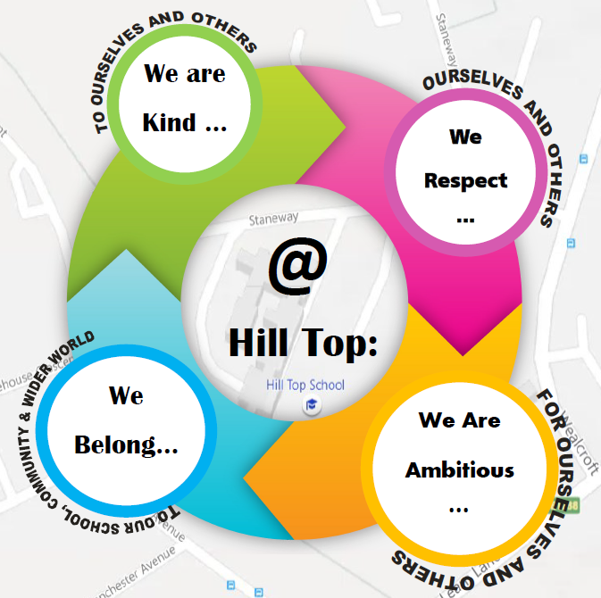

**AIMS**

Schools are required under the Equality Act 2010 to have an accessibility plan. The purpose of the plan is to:

• Increasing the extent to which disabled pupils can participate in the school curriculum

• Improve and maintain access to the physical environment

• Improve the delivery of written information to pupils

• Improving outcomes for all stakeholders

Our school aims to treat all its pupils fairly and with respect. This involves providing access and opportunities for all pupils without discrimination of any kind. All pupils attending Hill Top School have SEND (MLD, ASD associated learning difficulties plus a small number of SEMH pupils) and an Education Health Care Plan. We believe that no matter the special needs, all pupils have equal rights to an education and the correct amount of support to access the curriculum and learning environment to enable them to progress to their full potential. All pupils have access to the relevant curriculum with planned activities and visits to support the teaching and learning; additional support is provided to those pupils who require it to enable them to access school life. The plan will be made available online on the school website, and paper copies are available upon request.

Our school is also committed to ensuring staff are trained in equality issues with reference to the Equality Act 2010, including understanding disability issues. The school supports any available partnerships to develop and implement the plan. The school is a Gateshead Council maintained special school; therefore will take on advice and guidance from the Gateshead Equality Team, School Governor Support and Health and Safety.

Please contact the schools Head teacher Anita Bell if you have any concerns with regards to the Accessibility, if however you are not satisfied please follow the schools complaints procedure.

**Legislation and guidance**

This document meets the requirements of schedule 10 of the Equality Act 2010 and the Department for Education (DfE) guidance for schools on the Equality Act 2010. The Equality Act 2010 defines an individual as disabled if he or she has a physical or mental impairment that has a ‘substantial’ and ‘long-term’ adverse effect on his or her ability to undertake normal day to day activities.

Under the Special Educational Needs and Disability (SEND) Code of Practice, ‘long-term’ is defined as ‘a year or more’ and ‘substantial’ is defined as ‘more than minor or trivial’. The definition includes sensory impairments such as those affecting sight or hearing, and long-term health conditions such as asthma, diabetes, epilepsy and cancer.

Schools are required to make ‘reasonable adjustments’ for pupils with disabilities under the Equality Act 2010, to alleviate any substantial disadvantage that a disabled pupil faces in comparison with non-disabled pupils. This can include, for example, the provision of an auxiliary aid or adjustments to premises.

**Action plan**

**This action plan sets out the aims of our accessibility plan in accordance with the Equality Act 2010. Our aims are to:**

• Increasing the extent to which disabled pupils can participate in the school curriculum

• Improve and maintain access to the physical environment

• Improve the delivery of written information to pupils

• Improving outcomes for all stakeholders

**The information below (February 2024) sets out how the school will achieve these aims:**

This plan will be reviewed annually and updated every three years.

**AIM**

1. **Increasing the extent to which disabled pupils can participate in the school curriculum.**

• Hill Top employs a quality teaching first approach; the need for differentiation is continually emphasised and teachers’ responsibilities, as outlined in the national curriculum inclusion statement, are reinforced.

• Through robust administration systems key pupil information is sought on entry to the school, thus enabling individual pupil needs to be identified and met, this is support via section F (EHCP).

• The accreditation offered to pupils at KS4/5 varies vastly across the school in accordance with our diverse pupil need; this includes unit awards, Arts Awards, Entry-Level Awards, Functional Skills, NOCN and GCSE awards.

• Where necessary reasonable adjustments are made to ensure that pupils can attend school and have access to a suitable curriculum. Hill Top offers bespoke timetables and education packages tailored to individual need where necessary.

• Staff at Hill Top often work as part of a broader pupil centred multi-disciplinary team; advice is sought from these professionals in order to support individuals in school as appropriate.

• Staff at Hill Top share expertise within the school and with external professionals in order to meet individual pupil need. This can be done informally in meetings and the like or as part of a broader package of training events.

• Pupil voice is sought routinely and acted upon at Hill Top. There is an active school council. Pupils are always (where appropriate) involved in their annual reviews, and also in other meetings wherever possible.

• Specialist equipment and resources, intervention work and staff support is employed thoughtfully across the school in order to improve access to the curriculum for all individuals.

• It is a core value of the school that pupils are enabled to participate fully in the broader life of the school; therefore risk assessments and where necessary accessibility plans are considered and completed for extra-curricular trips.

1. **Improve the environment of the school to increase the extent to which disabled pupils can take advantage of education and associated services**

* Hill Top was built in 2014. It is a purpose built two storey school, built to a high specification in accordance with accessibility and health and safety laws.
* An Accessibility Audit Tool for Educational Settings will be used to ensure we meet the demands of a changing cohort at Hill Top.
* Work with the local authority to look at future proofing to meet the demands of a changing cohort e.g. create more break out spaces to support regulations, adapt classrooms
* Where necessary seek additional local authority funding will be sort to adapt to meet the needs of a changing cohort.
* Fire drills are carried out and evacuation plans are displayed and shared in accordance with the Hill Top health and safety policy.
* Where necessary individual evacuation procedures can be made for pupils and staff (PEEP).
* Members of staff make reasonable adjustments to the learning environment in order to meet the needs of any pupils with a disability; often following the advice of professionals such as the SENDCO or medical professionals.
* Training can also be organised in relation to these needs when deemed necessary.

1. **Improve the availability of accessible information for disabled pupils, and where necessary carers**

* Hill Top ensures that that key members of staff can use alternative methods of communication (including for example Makaton, PECS, communication mats, AAC devices). Training and resourcing for this is according to identified pupil need and supported by the school SALT.
* Where necessary communication in school is supported with objects of reference and symbols. This need varies greatly between pupils; advice in relation to this will be sought from home schools, pupils, parents and professionals.
* Where necessary communication around school is supported with signage and symbols.
* Staff at Hill Top seek and follow advice from medical professionals (such as Speech and Language Therapists, VI/HI teachers) re: the individual communication needs of pupils. Further staff training is arranged where necessary to meet this need.
* Reasonable adjustments will be made to support communication with school staff for any pupil or parent with communication needs, or who is visually or hearing impaired.
* Accessibility Plan is available online and in hard copy.

1. **Improving outcomes for all stakeholders**

* Hill Top staff will continue to have high aspirations and expectations for all of our pupils.
* Staff have regular and updated training re additional/individual needs and how the needs of the pupil can be met.
* All pupils are encouraged to take part in the whole curriculum including Music, drama, technology and physical activities
* Pupils (where appropriate) and their families are fully involved in annual reviews.
* Cover staff, including supply teachers, are clear about the additional needs of pupils at Hill Top.
* All staff build positive relationships with pupils, support flexibly and facilitating independent learning.
* Regularly review our curriculum offer to support our cohort of pupils, including sourcing alternative provision providers where it is not feasible to run courses on sight.
* Explore opportunities for work experience for pupils where appropriate.
* Travel train pupils (where appropriate) to support next steps and life beyond Hill Top.

1. **Monitoring arrangements**

This plan will be reviewed annually and updated every three years.It will be approved by Curriculum and Pupil Committee.

**5. Links with other policies**

This accessibility plan is linked to the following policies and documents:

•Risk assessment policy

• Health and safety policy

• Equality Policy

• SEND Policy

• Attendance Policy

• Home-school agreement

• School Development Plan