**Curriculum Intent:**

At Hill Top School, we have designed our curriculum with pupils’ learning at the centre. We recognise that a curriculum must be broad, balanced and offer pupils opportunities to grow as individuals as well as learners. Our school values the input of its pupils, parents and the local community with regards to the planning and delivery of the curriculum. We believe pupils get a well-rounded education if everyone is involved in shaping it.

It is our intention to provide a curriculum model that is primarily focussed on Preparation for Adulthood and preparing pupils for the next steps, whether that is the next Key Stage of their development or for their subsequent steps in life.  For some this may be college or work based learning, whilst for others it may be preparing them for adulthood, with as much relative independence and communication skills to ensure their safety and enrich their lives.

Our thoughts on curriculum design are that the current school cohort (and indeed, cohorts for the foreseeable future) are not best served by the National Curriculum alone. Our experience, concurring with a number of outstanding special schools, has led us to adopt a much more flexible and personalised approach, which sees our curriculum changing to meet the needs of the pupils rather than the other way round. Our learners are at the centre of our curriculum design.

We aim to ensure pupils enjoy learning and feel prepared for life after school. We also intend to offer our pupils new and exciting experiences through enrichment opportunities that are designed to build resilience, confidence and self-esteem. Our curriculum will be delivered in accordance with the Equality Act 2010, through a variety of methods.

We are currently implementing 3 pathways, within our curriculum as set out below, although we are aware that some pupils with complex needs may move between pathways at times. For more information, please see the curriculum overviews and subject specific intents.

1. **Informal Pathway**

A highly individualised approach, providing a suitable learning environment to meet the complex needs of pupils. Preparation for Adulthood for these pupils might be developing independence, developing communication strategies and choice making, to ensure pupils are able to enjoy happy and healthy lives. Staff are extensively trained to meet the medical, physical, communication and sensory needs of learners and activities are designed to build upon this foundation, in an appropriate, cross-curricular and highly sensory manner, with real life contextual experiences. Pupils work in a non-subject specific way and staff use elements of the engagement model, as well as strategies such as intensive interaction and attention autism, to underpin their planning for pupils.

1. **Semi Formal Pathway**

A holistic approach that makes links between key areas of curricular learning, in a creative and life skills context. To prepare these pupils for adulthood, there is an emphasis on independence, problem solving and communication skills, which are encompassed in the classroom and beyond, with regular access to the community to generalise their skills to real life contexts. There is a commitment to cross-curricular and contextualised learning where pupils are engaged and enthused in real life situations, within a flexible framework which is responsive to their personalised needs. The concepts of over learning and repetition are key in our semi-formal approach, to support the memory difficulties synonymous with pupils who have severe learning difficulties. To support the social and emotional needs of pupils, semi-formal groups are taught as individual classes, allowing consistency of teacher as support staff.

1. **Formal Pathway**

A subject specific approach that encompasses many elements of the National Curriculum, where appropriate for our pupils. The majority of pupils in this cohort continue their learning beyond Hill Top with appropriate providers or colleges. Support staff are designated to each group to maintain close relationships and ensure we continue to support the Social and Emotional needs of pupils. Pupil in the formal pathway will access accreditation where appropriate, to allow them to gain employment opportunities. These pupils are also supported to develop their independence in all areas of their life, to achieve independent living in adulthood.

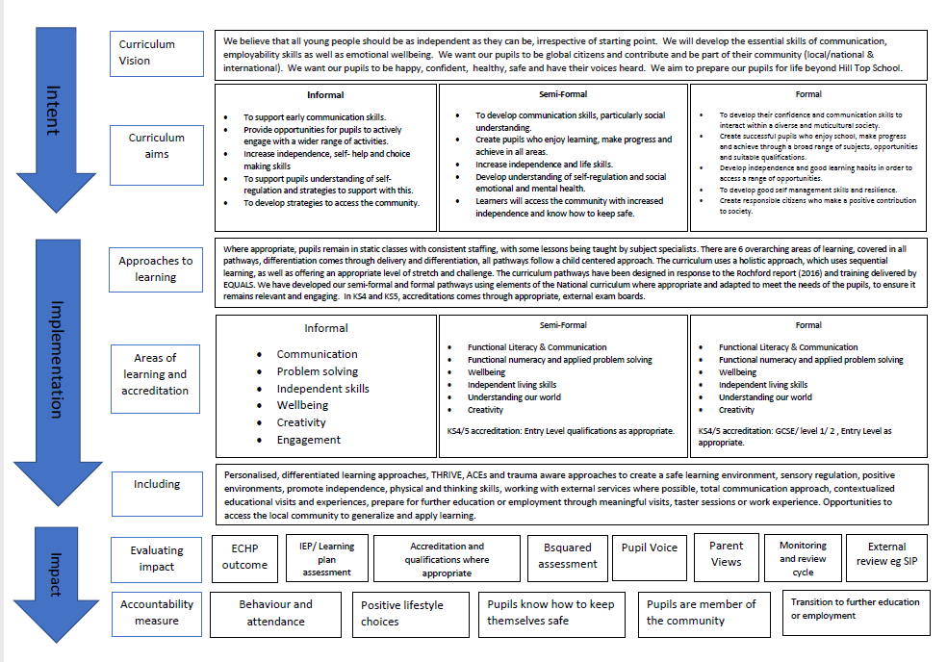

**Post- 16 provision**

Hill Top school has a small 6th form provision available for those pupils who need further support academically to achieve qualifications, before moving on to their next step. There are also pupils who aren’t socially or emotionally ready to access a college course and need additional time in a more nurturing environment. For those pupils in our autism centre we have an autism specific 6th form (from September 2021). In KS5 we continue with 3 specific pathways and the focus for all 3 is preparing for adulthood, on a level that is specific to the individual pupil.

