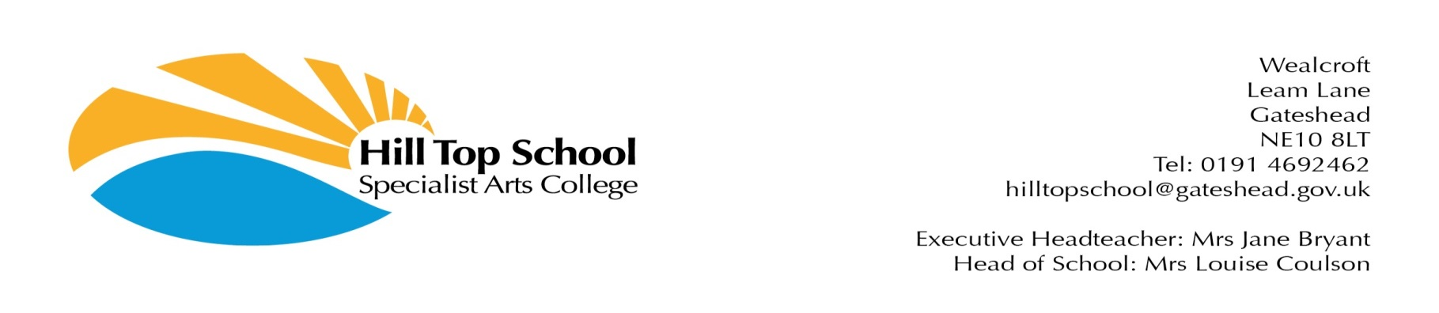

Wealcroft

Leam Lane

Gateshead

NE10 8LT

Tel: 0191 4692462

[hilltopschool@gateshead.gov.uk](mailto:hilltopschool@gateshead.gov.uk)

Head Teacher: Ms Anita Bell

**6.3.25**

Dear parents and carers,

A number of schools **(not Hill Top School)** in Gateshead this morning received information via email and took the appropriate safeguarding action as per their procedures.

As Northumbria Police we have made subsequent enquiries and deemed this not to be a credible threat.

To reassure you, there are no known concerns as a result of these malicious communications this morning and no schools need to be in lockdown.

Our officers are working with schools to help them work with you as parents and carers to reassure you your children are safe to remain in school today as normal.

I would urge people to remain calm and be reassured that the safety of your children is our number one priority.

If anyone has any further concerns they wish to raise with us, please contact do contact us

Chief Inspector Thomas Hart, Northumbria Police

Lead officer for Communities in Gateshead



