06/12/24
We have been playing time games and using new clocks that Mrs Dove gave us.
In science, we have looked at cells using a microscope.
We planned our own Anglo-Saxon village – some amazing designs.
In PE, we are learning to play basketball and in cooking, we used the hob to make scrambled egg, heat soup and make beans on toast.
In RE we were overlearning different religions and their festivals.
In PSHE, we watched Akeelah and the bee which covered racism and following your dreams.
In English, we wrote our own endings for Cloud tea monkeys. JC is getting very exasperated with Mrs Kelly because he really wants to hear the ending!!
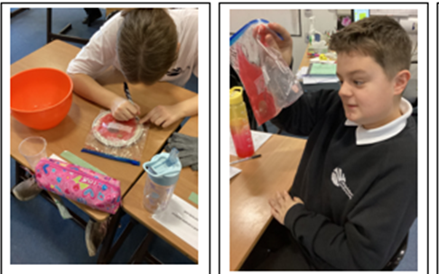

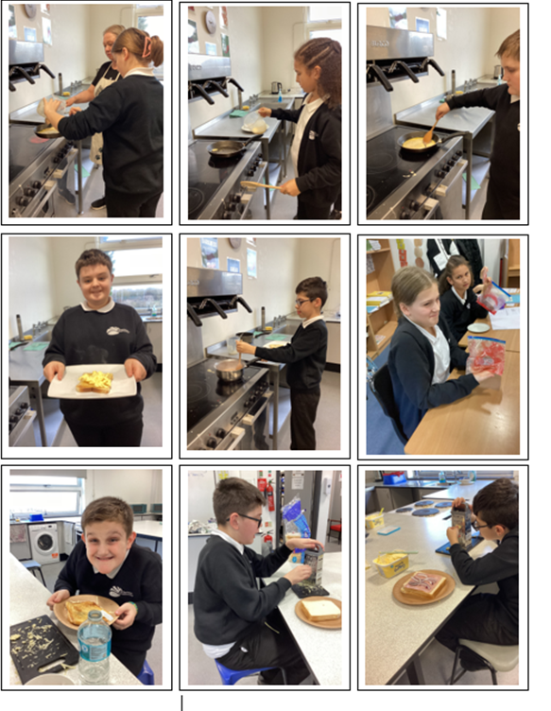

Christmas in Poland
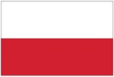

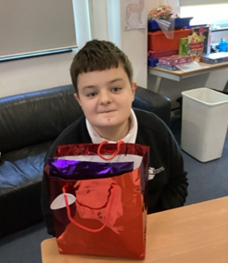
The Day of Saint Nicholas on 6 December is the unofficial beginning of the festive season in Poland. Well-behaved children receive small gifts on the day, whereas naughty children receive a lump of coal or a twig, called "rózga" (“roozga” ) OG received his first Christmas present today because he is a well-behaved young man!


13/12/24

We made cookies for the tea and coffee morning – we think they are soooo delicious. JS

We have been practising Last Christmas for the performance. ET

We were experimenting with onion cells and looking at them under a microscope. SE

We improved our letters to the tea monkeys. EA

I have worked really hard with my English – writing cvc words. RG

I have worked really well on Lexia and RWI. AI

I wrote a letter to the tea monkeys then I made it even better. AM

I have been writing a story ending and I am very proud of it. OG

I applied for a job as an Anglo-Saxon builder. My name was Lewyn! LD
