31/01/25
This week in A1 students have enjoyed the Chinese New Year sensory story called ‘It’s Lunar New Year’! Students enjoyed trying a taste of prawn crackers and enjoyed different sensory items in the story. Students worked well using the communication board to identify what they could see. In Math’s this week students have been learning about big and small and have been sorting objects into these two categories.
In food technology this week we have been continuing to work on peeling. Students practiced peeling an orange and then they cut up the orange into slices so that we could make an orange garment!
In wellbeing we have been continuing to play games and work on turn taking with staff and our friends!
In independent living we have been continuing to learn about road safety and sequencing the steps of crossing the road. Some students went outside to use the zebra crossing!
We have enjoyed our attention autism sessions where this week we made a big dragon for Chinese new year!
Some students have enjoyed their swimming session too.
With Miss Angus we have been learning about Georgian times and we made our very own fans! We enjoyed listening to music and playing on the keyboard.
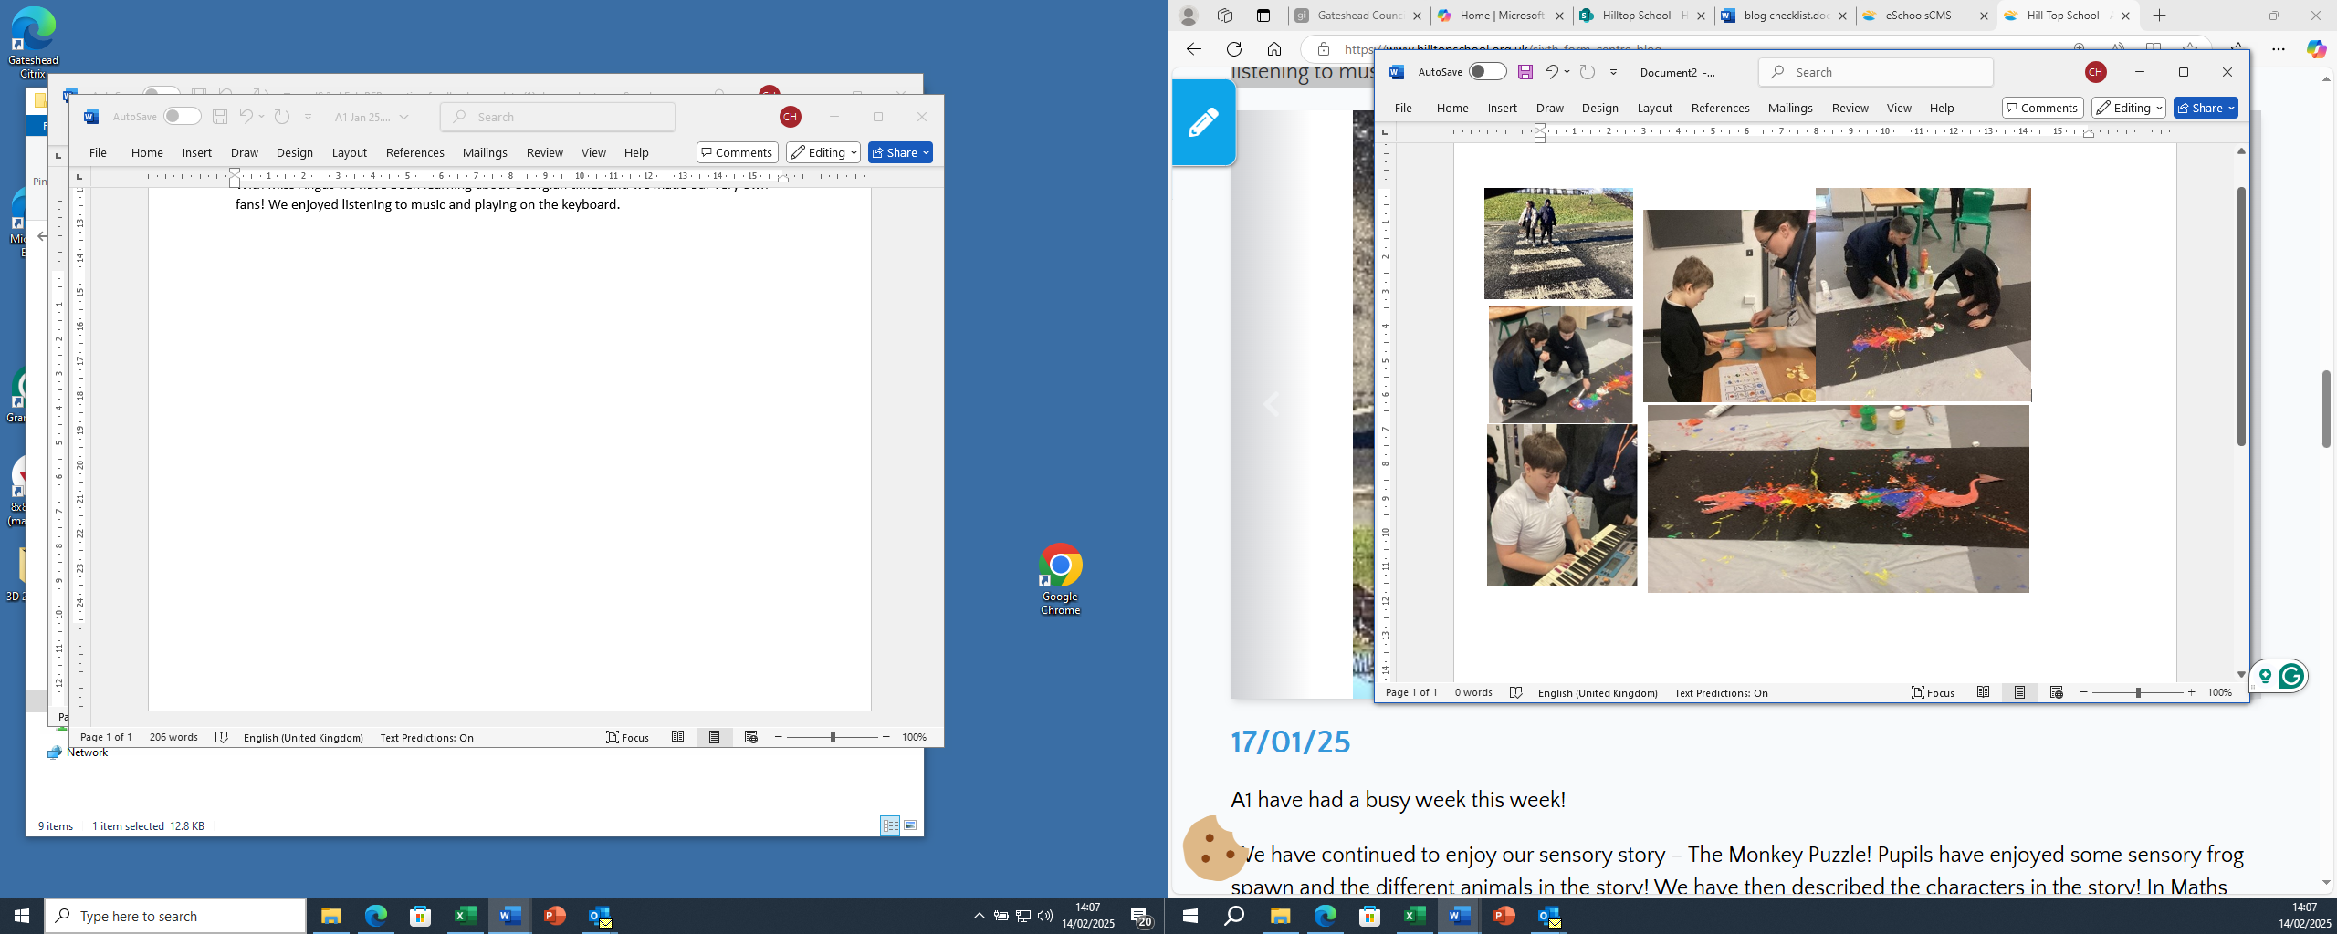

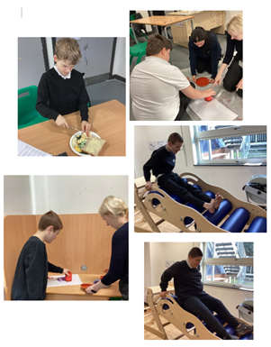
17/01/25
A1 have had a busy week this week!
We have continued to enjoy our sensory story – The Monkey Puzzle! Pupils have enjoyed some sensory frog spawn and the different animals in the story! We have then described the characters in the story! In Maths we have continued to enjoy our topic shapes, we have completed some shape printing with 3D shapes!
In Food technology we have focused on our skill peeling, we made some banana on toast! We have enjoyed our Attention Autism sessions and enjoyed the musical toys and some butterfly printing! In topic we have been learning about leadership and about our leaders in school and who helps us outside of school. We have enjoyed going to the movement room, sensory and iMuse.
We have enjoyed some sensory play.

10/01/25
A1 have had a lovely first week back at school! We have talked about what presents we got for Christmas and what we did in the holidays! We have started our new sensory story ‘Monkey puzzle’ and have enjoyed the different animals in the story. We have enjoyed learning about 2D and 3D shapes, we have enjoyed finding different shapes in flour and drawing them in shaving foam. We have made scrambled egg on toast in food technology and have enjoyed sensory play. We have also enjoyed our Attention Autism sessions and making a mess with paint! We have enjoyed or sensory and iMuse sessions and some pupils have enjoyed their first session back at swimming!

