31/01/25
We have had a lovely week in A6!
In English, we have continued to focus on our story 'Shark in the park', where we have used colourful semantics to create sentences.
In Maths, we have continued to look at 3D shapes and made a telescope like a character in our sensory story.
In PSHE, we have started to look at 'people who help us'. So, we have focused on doctors.
In understanding the world, we have focused on Lunar New Year and have made excellent snakes for the year of the snake.
In Food Technology, we have continued to look at Lunar New Year and our topic 'peeling'. We were able to peel an onion to make a stir fry.
In Life Skills, we have discussed keeping our homes clean and we were able to tidy a part of the classroom that was messed up.

We have also continued to complete phonics sessions, community skill sessions, bucket sessions, sensory room, I muse and sensory play time as well.
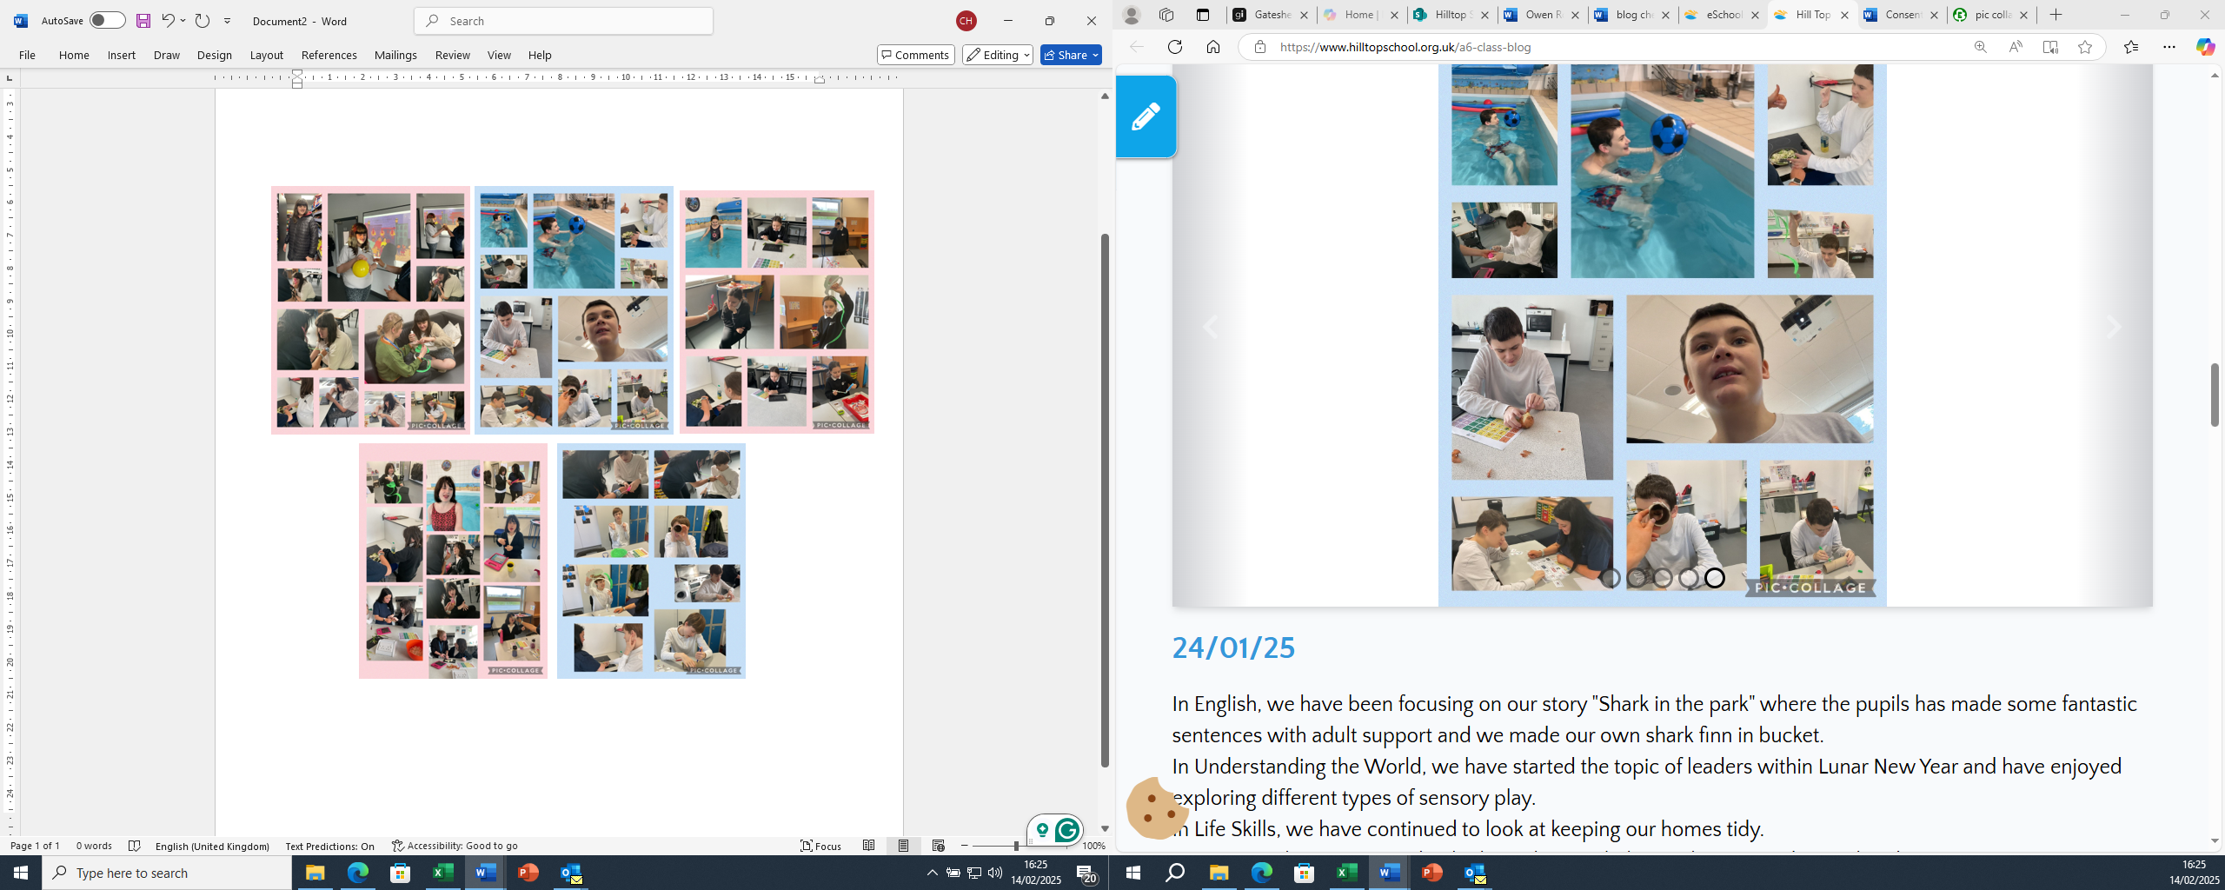
24/01/25
In English, we have been focusing on our story "Shark in the park" where the pupils has made some fantastic sentences with adult support and we made our own shark finn in bucket.
In Understanding the World, we have started the topic of leaders within Lunar New Year and have enjoyed exploring different types of sensory play.
In Life Skills, we have continued to look at keeping our homes tidy.
In PSHE, we have continued to look at what can help us when we're dysregulated.
We have also continued with phonics, sensory room and I muse, movement room and bucket.
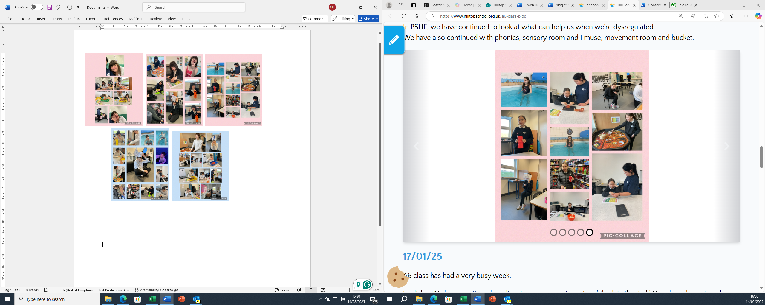

17/01/25
A6 class has had a very busy week.
English - We have continued readingat our sensory story story 'Shark in the Park'. We ahve also enjoyed doing Sensory Play and Communcation.
Maths - We have continued looking at different 3D shapes and exploring why they are different to 2D shapes and we have sorted the different shapes into the correct areas.
Food Technology - We continued with our topic 'peeling', where we were able to peel and cut a banana and an orange to make a banana and a Orange smoothie independently.
PSHE - We have continued looking at different strategies to help us self-regulate with different sensory activities.
Life Skills - We have been continuing to look at how to clean our houses, so we have been practicing washing and drying our plates and cups.
We have also completed community skills sessions twice! The first trip was to the shop where everyone listened to instructions and bought some lovely treats. The second trip was to the Hydro pool and everyone loved it.
We also had lots of sensory play, bucket time, sensory room, movement room and iMuse time.
10/01/25
English - We have been looking at our new story 'Shark in the Park'.
Maths - We have been looking at different 3D shapes and exploring why they are different to 2D shapes.
Food Technology - We focused on our new topic 'peeling', where we were able to peel and cut a banana to make a banana smoothie independently.
PSHE - We have been looking at different strategies to help us self-regulate.
Life Skills - We have been continuing to look at how to clean our houses, so we have been practicing washing and drying our plates and cups.
We have also completed community skills sessions twice! The first trip was to the shop where everyone listened well to instructions and bought some lovely treats. The second trip was to the Hydro pool and everyone loved it.
We also had lots of sensory play, bucket time, sensory room, movement room and iMuse time.
Hope you all hve a lovely weekend.
Miss Collins, Mr Dixon, Miss Bradshaw, Miss Hutchinson

