06 /12/24
Highlights of the week:
We are enjoying getting ready for the performance on Thursday 12th December - as individuals most of us are involved in some way and some of us have more than one role. Next week is the ‘Big Day’; we are a little nervous!
Some of us, when not called for the performance, took to decorating the classroom for Christmas and it looks very festive. Our 15 metre paper chain, representing the Ghost of Marley’s chain, was too big for the board and had to be dismantled and put elsewhere (at least that hopefully happened to Scrooge!)
Learning:
We each came up with a descriptive sentence for the Ghost of Marley in ‘A Christmas Carol’ for English using adjectives, similes and metaphors and put all our ideas together. There were some interesting ones. In maths we played a game with the four operations of maths with Mrs Allison which was fun as we had to win points. In PSHE we discussed how to look after the planet and thought about what was the most important; some of us could give reasons as well. We also watched Newsround as they had a report of plastic being put into foreign countries and explored the consequences of that. We were shocked at the images from the programme and how that hurts the sea life. 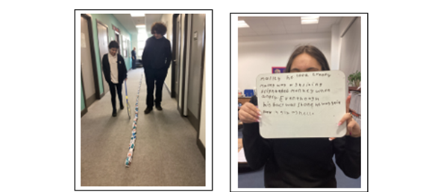
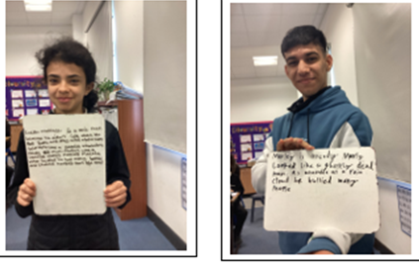
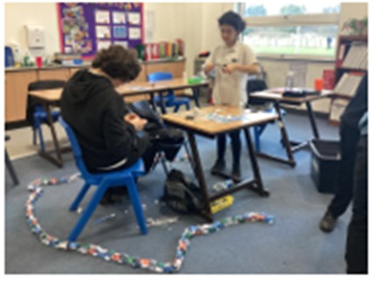

13/12/24

A fantastic ‘all hands-on deck’ week of rehearsals this week and the class and their peers did exceedingly well…
Christmas Performance of ‘Sounds of Christmas’: majority of the class took on a responsibility for one role and a few took on more – we are so proud of their commitment and dedication to the performance and how they supported each other and their peers in other classes.
As part of the backstage crew, MH knew his responsibilities and checked with the performers that they were happy with microphone height, which is daunting in itself in front of a crowd. Many were involved with singing as ‘Voices’ which brought joy of participation across all year groups. Some of our performers in the class did soloist singing and have beautiful voices but have the confidence to perform in front of an audience with strangers. I do wish to acknowledge a beautiful singer in our class who had such a presence on the stage and ‘smashed it out the park’. The ‘secret’ contemporary physical theatre dance they took part in was amazing, and as a surprise, added an extra flair to the variety of genres the whole show offered.
We are so proud of BP, MT, AS, CA, MH for contributing their best to a fantastic production. Well done for giving yourself those opportunities to experience something new as you prepare for life beyond Hill Top School. You are flying with enthusiasm and success!

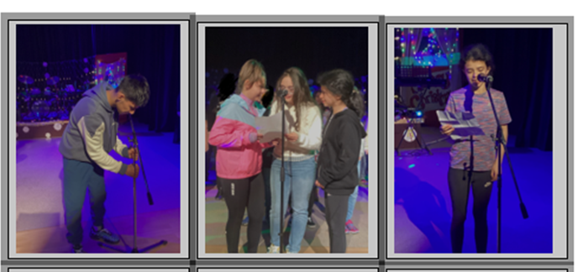

20/12/24

We’ve all been excited for breaking up for Christmas! Mr Pallas organised a basketball interhouse tournament in which MH did extremely well, but we won’t find out the results of the house who won until Friday. We had our Christmas dinner with Christmas crackers and dressed up tables followed by singing festivities and a great disco on Wednesday. Thursday morning, we travelled to Newcastle for our outing and went to see Fenwick’s Christmas window with the theme of the 12 Days of Christmas and Newcastle Christmas market. We went with 4B and had a great time together going to various shops. MS was fantastic and met his EHCP target twice by telling the bus drivers the destination he wanted and paid for his tickets independently. In the afternoon all the KS4 classes had social time together and played games or sat and chilled. Friday will be a whole school assembly and then preparing for the New Year and term.
This week w we also made Christmas cards, did some Christmas maths activities, completed our English assessment on A Christmas Carol and discovered about plastic pollution. A busy week!
Merry Christmas to you from 4C.
