31/01/25
In maths we have been making shape pictures and then identifying rectangle and cylinder while we made our Chinese lantern to celebrate Lunar new year. We watched our story Monkey puzzle on YouTube. In understanding the world, we peeled boiled eggs and made egg and cress sandwiches with our home-grown cress! We have been making our own crown and decorating it with different jewels. In music we were playing the drum and we all enjoyed it. In food technology we made fruit salad. Everyone tried hard to peel their apple but could manage peeling banana and oranges. They all cut the fruit themselves, and some ate it all up. Two boys enjoyed hydro and the other three pupils are pleased the swimming pool is fixed!
Have a lovely weekend.
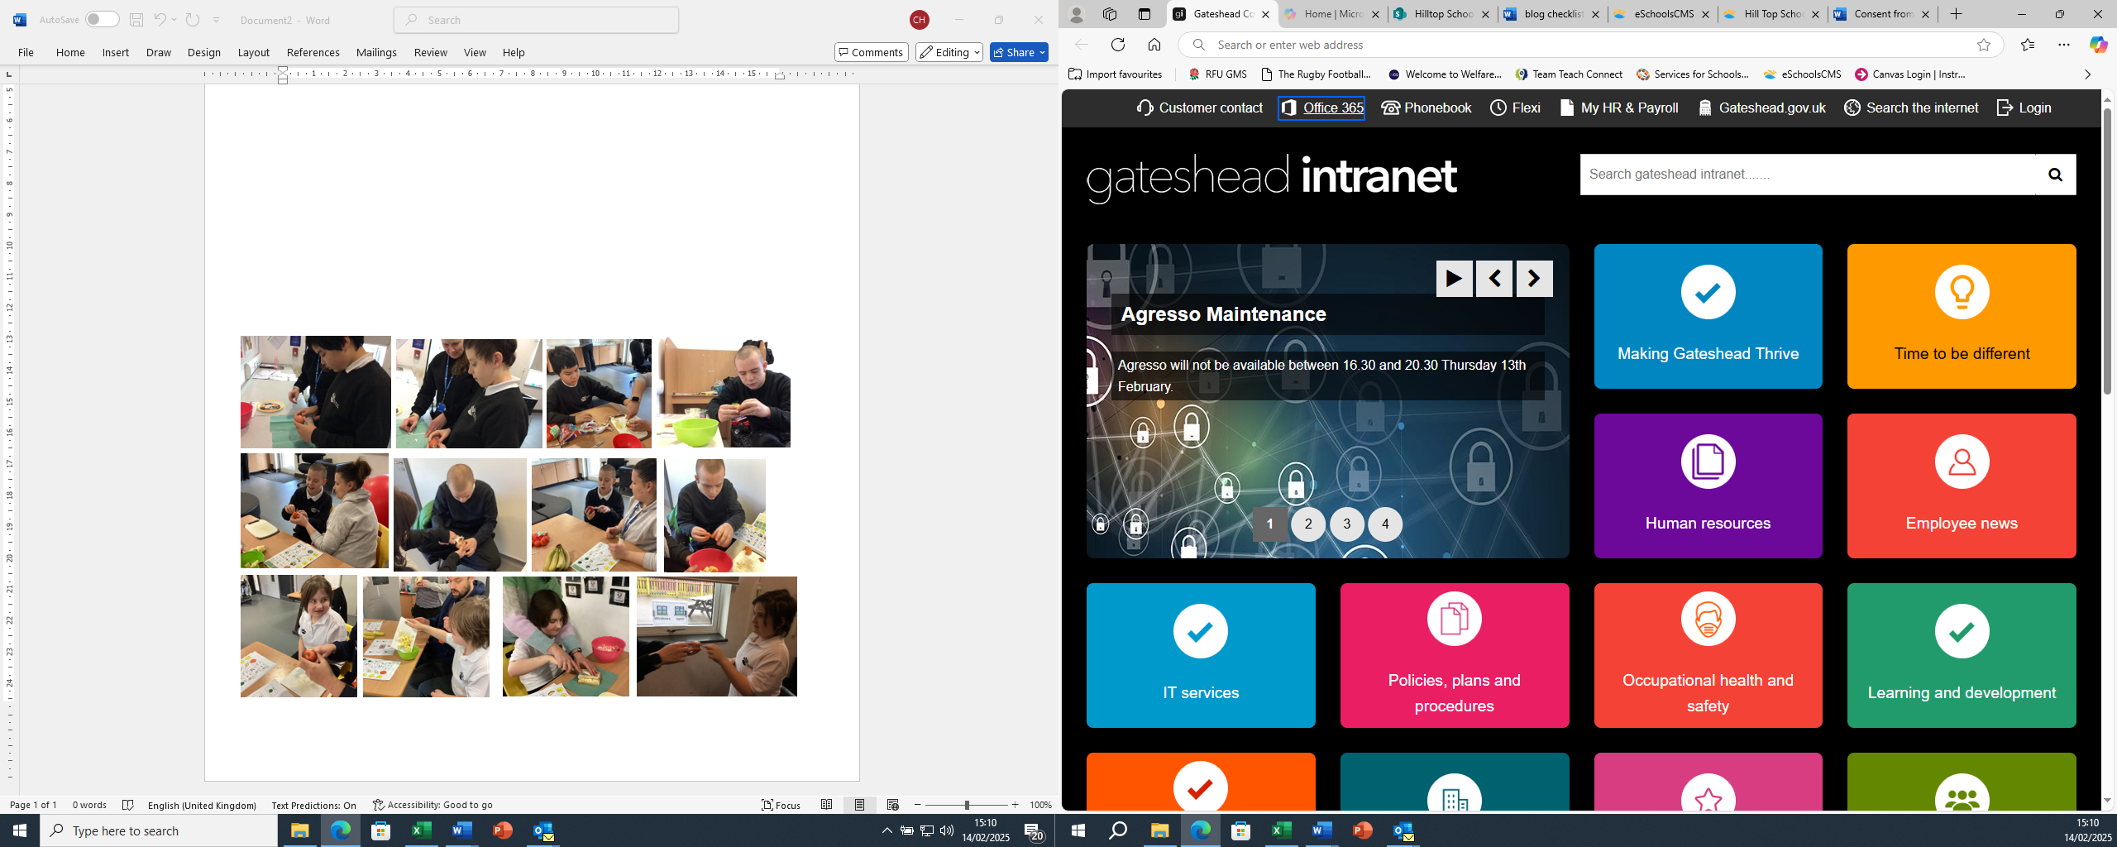

24/01/25
In maths we have continued to look at shapes and made pictures with them. In food technology we have practised peeling, this time apples and we made an apple crumble in the air fryer. Our sensory story is Monkey Puzzle, and we have been listening to the sounds of each animal and played sound bingo. We have also been describing the animals. In understanding the world, we have looked at the leader Queen Elizabeth II and learnt she lived in a palace and a castle and then we looked at other London landmarks. We then watched Paddington Bear and the Queen ‘video clip’ from the Jubilee concert and learnt they both like marmalade sandwiches! We then followed instructions to make our own marmalade sandwich.
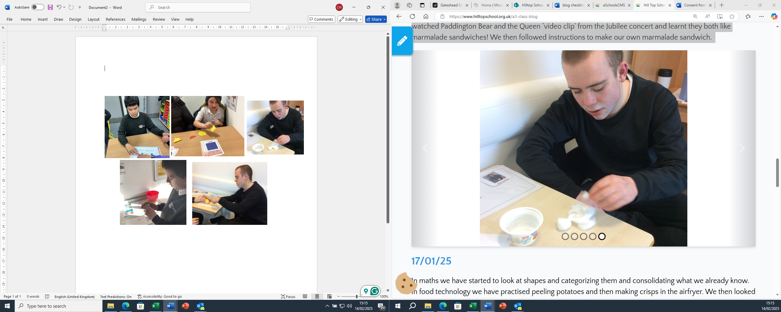

17/01/25
In maths we have started to look at shapes and categorizing them and consolidating what we already know. In food technology we have practised peeling potatoes and then making crisps in the airfryer. We then looked at making choices and tasted the crisps and shop crisps and said which we liked. We have also chosen which picture we wanted to make into a puzzle. Our sensory story is Monkey Puzzle and we explored all the elements and then looked at adult and baby animals. In art we looked at female leaders and we looked at shiny materials to make a rocket. In understanding the world, we looked at the leader Kind Charles III and made a collage. We learnt that the King likes plants and looking after the world and we planted cress seeds.

