31/01/25
This week in A2, we have been looking at Chinese New Year as part of Understanding the World, and enjoyed a sensory story, Lunar New Year. For attention autism, we did a special Holocaust memorial session. We have enjoyed lots of artwork this week based on our topics.
In food technology have made some breadstick snakes! They were very tasty and it helped us practice our chopping skills.
In Maths, we have been looking at symmetry, and made beautiful butterflies. With Miss Angus, we looked at Georgian times and made and decorated our own fans.
We enjoyed doing some teamwork with the parachute, taking turns holding it and going under it, lots of fun!
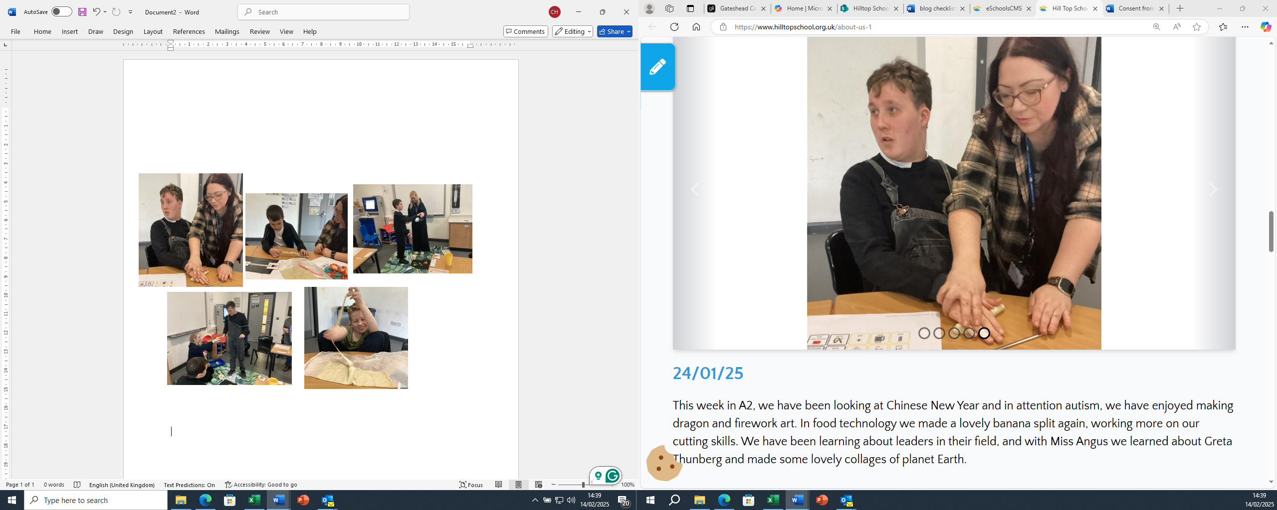

24/01/25
This week in A2, we have been looking at Chinese New Year and in attention autism, we have enjoyed making dragon and firework art. In food technology we made a lovely banana split again, working more on our cutting skills. We have been learning about leaders in their field, and with Miss Angus we learned about Greta Thunberg and made some lovely collages of planet Earth.

In English, we have also been continuing with our sensory story, Monkey Puzzle and we have worked on identifying feelings. using characters from the book. In maths, we are looking at pattern recognition, and some of us are creating our own patterns. Have a great weekend everyone!
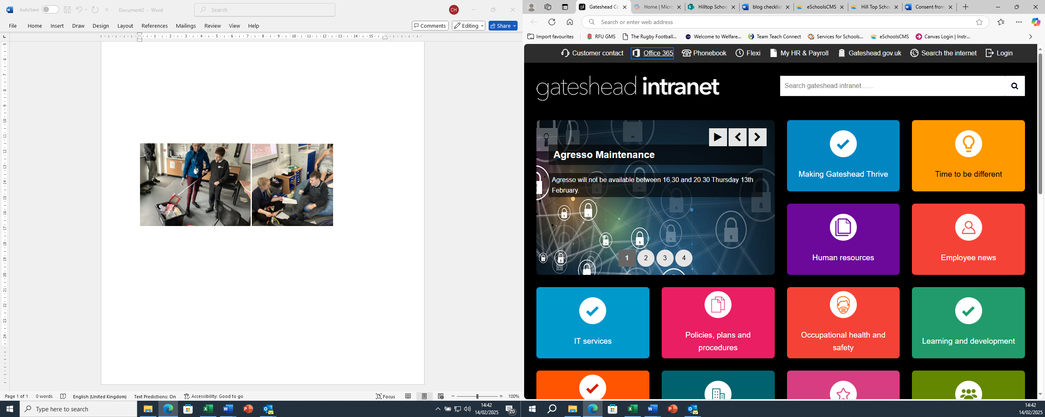

10/01/25
This week in A2 we did very well settling back in after our Christmas break. We have started our new sensory story, “Monkey Puzzle” and we are enjoying it very much. In our understanding the world lesson, we watched part of a David Attenborough documentary and then completed an activity identifying which animals live in different habitats.
We have also been looking at “leaders in school” as part of our topic. In maths, we have continued looking at 3D shapes and pattern recognition. We have enjoyed some collage artwork with Miss Angus, and in food technology, we’ve also made a yummy fruit salad, learning how to peel and chop fruit…delicious! Have a great weekend everyone.
