06/12/24
Two weeks and counting!
3C have been in and out like the ‘Hokey Cokey’ this week with headaches, poorly stomachs and ‘the bug.’ However, those who have made it in have been kept busy in English with reading and work on prepositions. In Maths we have been continuing with Time, especially digital time. This has meant a lot of counting in 5’s around the clock and remembering when you write digital time you start with the hours first. Science has involved looking at the functions of the ear. We listened to frequencies and put up our hand when we could no longer hear them. In PSHE we talked about how to present ourselves for interview and how best to behave when in an interview situation. In ICT we continued to explore Paint. And finally, some students were shown how to iron clothes safely. All in all, a busy week.
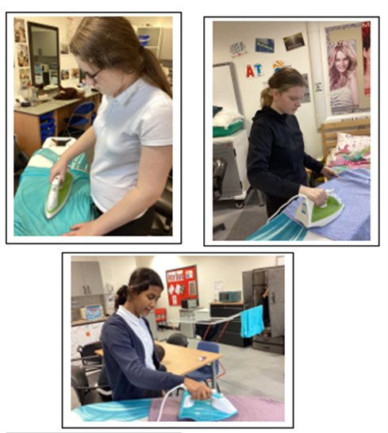
13/12/24
The final countdown……
What a week in 3C. There have been tears, tantrums, fun and laughter. Yes ….. the school production, has been perfected and the thespians/singers from 3C were perfecting their stage presence.
However, before the final performance the students in 3C visited Newcastle Central Mosque with Mrs. Hayden, Ms. Shaw, Mrs. Whitehead and Mr. Musham (who kindly drove them there.) Brother Khadim told them a story about the ‘the smallest prayer mat.’ He asked the students to guess who it was for? It turned out it was for a mouse……not a four-legged rodent but a mouse for his computer! I was very proud as the students were well behaved and asked some pertinent questions. We are looking forward to visiting again.
By Thursday, tissues were ready and vocal cords warmed up for the production of the year, a singing sensation of Christmas medleys, acting and superb playing from the musicians. MT and VD sung their hearts out. KK gave us some ‘groovy moves.’ LS brought tears to the eyes of the audience with her beautiful singing and IM shone with her superb performance on the Xylophone. Not forgetting the newest member of the stage crew ALH who was responsible for the curtains.
Well done to all of the other wonderful participants, Mrs. Pearson you did us proud. x

