31/01/25
3a have had a really good week – we are all concentrating on a strong start and responding very well to this- despite the very windy weather!!
Science: We made a fact file for our favourite planets then presented these to the class
English: We have been reading Street child, describing Jim Jarvis and choosing similar words to those in the text.
Maths: Adding and subtracting number to 100 then above 100! WE know that we can add in any order but its easier to start with biggest number. In fast maths, we are adding 2 and 3 on to every number and subtracting too.
ILS: We are learning to look after our clothes by folding and looking at clothing labels.
PSHE: We have been learning why we have money and learning to prioritise what we buy.
Humanities: We watched an interview with Mala Tribich who was a prisoner during the Holocaust.
ICT and Art: We have been working on our Enterprise task using different media.

24/01/25
3a have had a really good week – we are all concentrating on a strong start and responding very well to this- despite the very windy weather!!
Science: We made a fact file for our favourite planets and then presented these to the class.
English: We have been reading Street Child, describing Jim Jarvis, and choosing similar words to those in the text.
Maths: Adding and subtracting numbers to 100, and then above 100! W2 know that we can add in any order but its easier to start with biggest number. In fast maths, we are adding 2 and 3 on to every number and subtracting too.
ILS: We are learning to look after our clothes by folding and looking at clothing labels.
PSHE: We have been learning why we have money and learning to prioritise what we buy.
Humanities: We watched an interview with Mala Tribich who was a prisoner during the Holocaust.
ICT and Art: We have been working on our Enterprise task using different media.
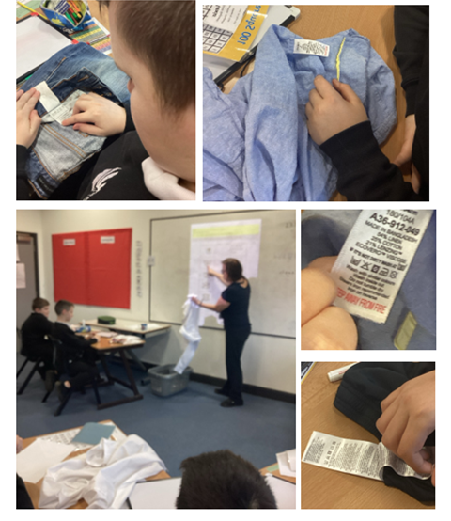
17/01/25
In English, we are learning how to use adjectives to describe characters and how to make longer sentences using conjunctions. We are starting to read Street child by Berlie Doherty.
In Maths, we are reviewing work on time: o’clock, half past and quarter to and past. Some of us can read all the times of the clock and convert to digital!
In Independent living skills we are starting to care for our clothes and Mrs. Kelly has been very impressed with how much we know!
We are learning to budget in PSHE and this is helping with our Enterprise activity - we would like to make enough money to go to Holmside Park.
We have also been learning about castles, keyboards, circuit training, the solar system and stained glass windows (Christianity).
We have returned to the swimming pool this week and we are so impressed with the behaviour!!
Well done 3a from Mrs Hymers and Mrs Kelly.

