31/01/25
There’s been lots going on in A4 class this week.
In English we continued reading our story The Barnabus Project and we thought about how the main characters were feeling during different scenes in the story. In Maths we did a 3D shape hunt before building different shapes with ice lolly sticks and playdoh and identifying how many faces, edges and vertices each shape has.
In Understanding the World, students celebrated Lunar New Year by trying a range of Chinese food and drinks, such as spring rolls, hoisin sauce, pocky sticks and aloe vera juice and discussing our preferences. Students also made noodles in our cooking lesson and snakes from paper plates to celebrate the year of the snake.
We discussed road safety and then put it into practice when going on our Community Skills visit.
Students have also accessed the sensory rooms, movement room and rebound therapy as well as music therapy.
Well done A4, another great week

Class certificate goes to JW for his contribution to our phonics session.

24/01/25
There’s been lots going on in A4 class this week.
In English we continued reading our story The Barnabus Project and we have analysed the main characters and setting.
In Maths we have looked at 3D shapes, naming them and thinking about their properties.
In Understanding the World, students have practiced putting on a bandage and then thought about what we might need to use when we injure ourselves.
In cooking we made sweet potato fries with masala seasoning. Student demonstrated excellent peeling and chopping skills with good safety in the food room. The fries were a big hit.
We have also enjoyed learning about Chinese New Year, talking about the traditions of the festivities and finding out which Chinese zodiac sign we are.
Students have accessed the sensory rooms, movement room and rebound therapy, as well as music therapy.
Well done A4, another great week.
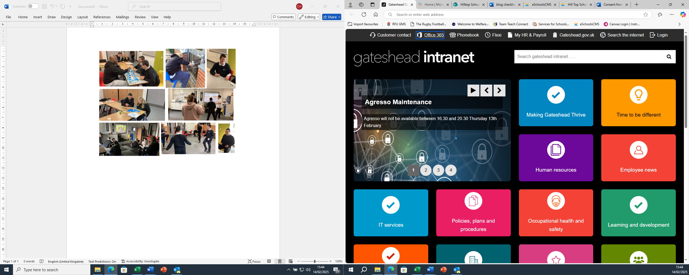
17/01/25
It’s been a busy week in A4.
A4 have consolidated their work on shapes and discussed the properties of 2D shapes, understanding the difference between a straight and a curved line and identifying them in the classroom.
Students have started their new story called The Barnabus Project. It has been a big hit in A4 with the students captivated by the beautiful illustrations and storyline.Students were able to identify and describe the main characters and setting.
In ILS students have explored our first aid kit, with discussions and demonstrations if how and when to use a variety of basic medical kit, such as plasters, wipes and bandages.
In Cooking. students made chips in the air fryer and were able to demonstrate excellent peeling and chopping skills. Students and staff enjoyed trying what had been prepared.
In Understanding the World, we have discussed leaders in the school, identifying who they are and what their jobs are.
Students have also deployed a range of regulation strategies such as playing with dried rice, magnets and playdough, as well as colouring, being outside and rebound therapy.
Another great week for A4 class. Well done!
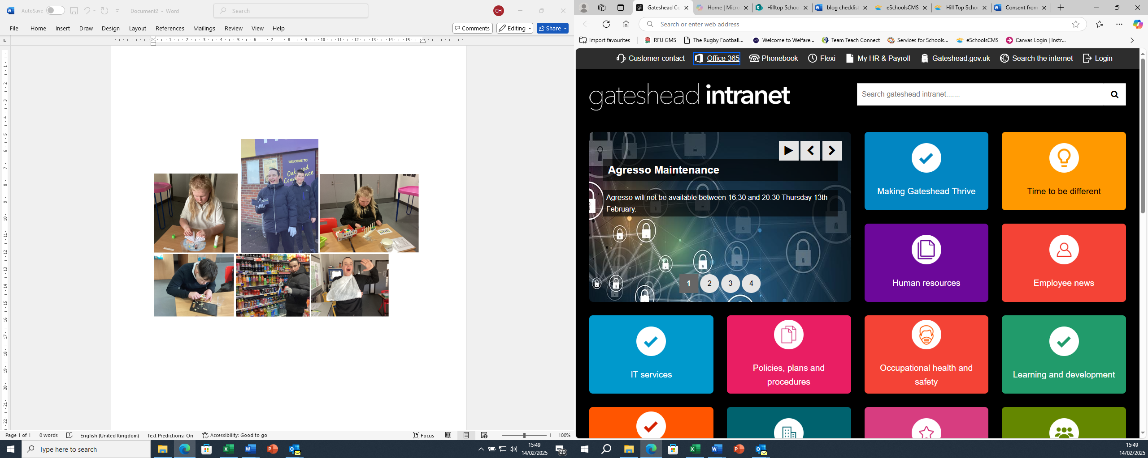

10/01/25

It has been lovely to have the students back to school after a wonderful winter break and we are all ready for another fun half term.
In Maths we have worked hard at remembering the names for 2D shapes and their properties, as well as practising our arithmetic using a hundred square.
In Understanding The World, we have talked about the New Year, when it is celebrated, how people around the world celebrate it and what a new year resolution is. Students thought about what they would like to do differently this year with some deciding to be more active and others saying they will keep their rooms tidy!
In Food Technology we made carrot crisps, as this half term we are practising how to peel fruit and vegetables. Students were able to identify which food needed to be peeled, which equipment we can use to peel, as well as discussing top tips for peeling safely and effectively.
Students enjoyed planning for and going to Oakwood shop in Community Skills. When at the shop they are able to choose what they wish to buy, hand over their money and receive change. In Independent Living Skills, they demonstrated their skills in looking after clothing. Some students sorted out laundry into the correct colours for washing whilst others put the washing into the machine correctly and folded up dry washing.
During our wellbeing session, students thought about zones of regulation and what might cause them to have different emotions. Students said that meeting a monster would make them scared and linked that to a blue emotion.
Students have also worked hard at their phonics, drawn on a range of techniques to aid regulation and spent time in the fresh air.
